React Native Expo Project
Progress Log
Student Name: ___Katellyn Hyker_____________________________________
App Name: ______InnerBloom__________________________________

Progress Made

- Created new github repository and expo app
- Created some simple starting pages
  - Homepage – welcomes the user to the app
  - Journal page – Displays journal entries or displays there are none
  - Entry Page – Allows the user to type up an entry that displays on the journal page
- Added bottom tab functionality to swap between pages
- Re-organized file and app.tsx information for a cleaner file structure
  - Different screens now have individual files
  - Style is now done in its own file
  - Entries type was moved into its own file

Design Updates
Include screenshots or images of your app screens below.
No major design changes yet
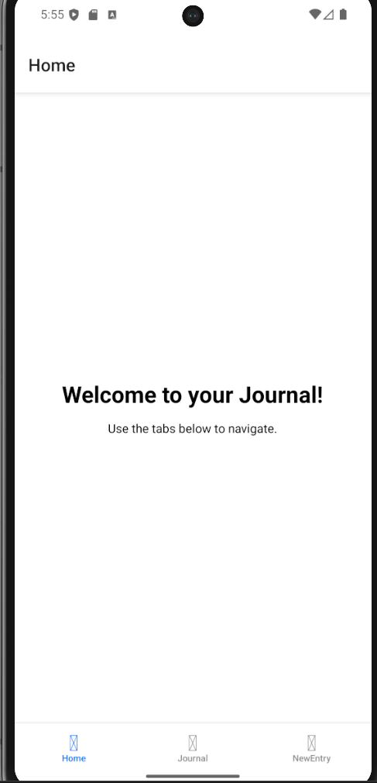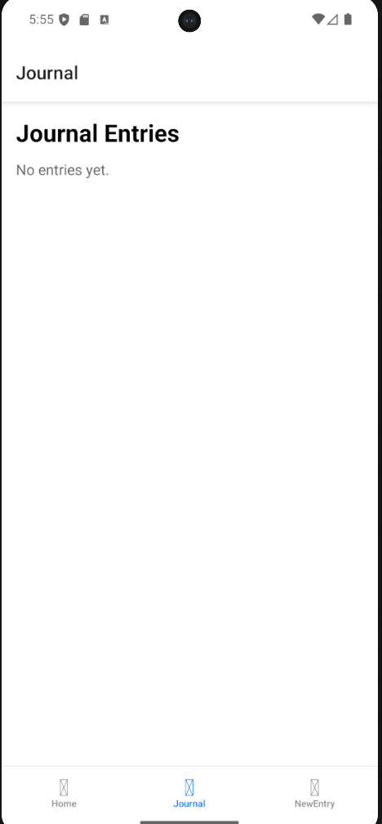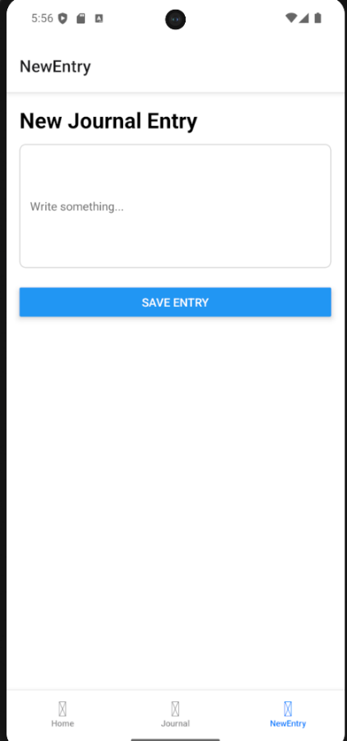

Issues / Blockers

- Within the new entry screen upon click of save entry button the keyboard does not disappear in android simulator.
  - Plan: have the button also automatically switch to the journal screen
- OLD ISSUE: The bottom tabs were causing an issue with the project to run completely on any device.
  - FIX: installed additional react features in the terminal and added 1 line to app.tsx
    - npm install @react-navigation/native @react-navigation/bottom-tabs react-native-screens react-native-safe-area-context
    - enableScreens(false);
Next Steps

- Fix entry screen issue.
- Complete general design desired for each existing screen
- Create basic habit tracker screen

